Vanishing Voices
Home for millennia to the majority of Canada’s Native tongues, BC has recently been designated an endangered language hotspot.
By Lori Thicke, MFA’86
“It’s lonely when you’re one of the last speakers,” says Michele Johnson, PhD’14. “You’ve got no one left to talk to.” At the age of 46, Johnson has found her life’s work – her chawt – in saving the nsyilxcən language from dying out with the last few elders who speak it natively.
Johnson is a language activist, a language teacher and a passionate advocate for indigenous languages. One of UBC Okanagan’s first two Aboriginal PhD graduates, she learned the language of her father’s nation through the remaining elders. Now she is trying to create enough new speakers to bring it back from the brink of extinction.
Michele Johnson is determined to prevent the nsyilxcən language from dying out.
After two years of intensive study, Johnson is an intermediate speaker of nsyilxcən – also known as Okanagan, or Interior Salish – and sufficiently proficient to teach a community class of adults – plus, as she puts it, “one extremely persistent 13-year-old.”
With fewer than 100 native speakers of nsyilxcən left, this work couldn’t be timelier. But nsyilxcən isn’t the only language at risk. All Aboriginal languages across Canada are considered endangered.

First Nations, First Languages
Before the arrival of the European settlers, North America was home to hundreds of indigenous tongues. Even though many have now disappeared due to colonization, there are still more living languages in Canada and the United States than in Europe. The Ethnologue – a catalogue of the world’s languages – counts 313 Native languages north of the Mexican border versus 280 for all of Europe.
In 2011, the national census reported more than 60 Aboriginal languages in Canada. Over half of them are found in just one province; British Columbia’s coasts and valleys have been home, for millennia, to the majority of Canada’s Native tongues.
BC’s pocket of linguistic richness has attracted the attention of National Geographic, which, along with the Living Tongues Institute for Endangered Languages, recently designated the province as one of the most endangered language hotspots on the planet, threat level: severe.
The “hotspot” designation refers not only to the sheer number of languages at risk, many of which were traditionally spoken in a single valley, but also to the unusual linguistic diversity. BC’s indigenous languages come from seven distinct language families, with two isolates (languages possessing no known relatives), compared with just three language families in Europe (with Basque as the sole language isolate).
For people like Michele Johnson, this diversity of languages, almost unparalleled in the world, is a heritage worth preserving.

Kill the Language to Kill the Culture
First Nations communities lost everyday use of their languages over the course of the last century, when generations of children as young as five were taken from their families and confined in residential schools whose main purpose was to assimilate them by cutting them off from their culture and their language. Punishments for children who were caught speaking their own language, even if they knew no other, included beatings, shaming, food deprivation and needles shoved in their tongues.
In the book Stolen from our Embrace, former Musqueam Nation chief George Guerin recalls that “Sister Marie Baptiste had a supply of sticks as long and thick as pool cues. When she heard me speak my language, she’d lift up her hands and bring the stick down on me. I’ve still got bumps and scars on my hands. I have to wear special gloves because the cold weather really hurts my hands.”
“Language is directly related to culture. Who you are can only be expressed properly in your own language.”
According to Patricia Shaw, founding chair of the UBC First Nations Languages Program and a professor in the Department of Anthropology, “the residential schools very frequently would not only refuse to let the kids speak their languages to each other – and they came in monolingual – but they also spoke of the languages as being primitive, as the language of the devil, so the children internalized those beliefs. Now they are beginning to see that these languages are rich and a unique cultural heritage. But that psychological trauma of having had their personal and cultural identities so devalued has had a huge impact.”
This failed policy of residential schools, the subject of a recent exhibition at UBC’s Museum of Anthropology, all but wiped out the indigenous languages. The scars can still be seen today in Canada’s Native communities, which suffer disproportionately from poverty, marginalization, violence, addiction, malnutrition and suicide. A 2013 study by the Canadian Centre for Policy Alternatives and Save the Children Canada found that half of status First Nations children live in poverty. In a 2011 fact sheet, the Assembly of First Nations concluded that “a First Nation youth is more likely to end up in jail than to graduate high school” and that “suicide rates among First Nation youth are five to seven times higher than other young non-Aboriginal Canadians.”
In 2007, researchers Michael Chandler and Darcy Hallett from UBC and Christopher Lalonde from UVic found a correlation between Aboriginal language knowledge and youth suicide. In communities where fewer than 50 per cent of the elders retained some knowledge of their language, they found that young people were six times more likely to take their own lives.
Youth suicide is a powerful indicator of extreme community distress, and the researchers found language health was the strongest of six key indicators of community health. The youth suicide rate “effectively dropped to zero in those few communities in which at least half the band members reported a conversational knowledge of their own ‘Native’ language.”
Musqueam elder and UBC adjunct professor Larry Grant is not surprised by this finding. “The importance of language is that it grounds the youth, and the ones without language don’t have something to ground them,” he says.
Like Johnson with nsyilxcən, Grant is engaged in his own battle to preserve his language after the last native speaker of the Musqueam dialect of hən̓q̓əmin̓əm̓ (Halkomelem) died in 2002. “The major challenge,” he says, echoing Johnson on the loneliness of the last speakers, “is that we don’t have speakers, and the ones that are trying to speak don’t have anyone to speak to.”
Grant, who was born and raised in the Musqueam territory, co-teaches with Shaw at UBC, but originally joined the First Nations Languages Program in 1998 as a student after retiring from a 40-year career as a tradesman. On completing his second year, he was offered a contract to teach.
Gerry Lawson also sees a strong community imperative for revitalizing Aboriginal languages. A member of the Heiltsuk First Nation, Lawson is the coordinator for the Oral History and Language Lab at UBC’s Museum of Anthropology. Working on a project called Indigitization, funded by the Irving K. Barber Learning Centre at UBC, Lawson has assembled a toolkit to digitize First Nations oral history and language to preserve them for future generations.
“Facilitating cultural and language revitalization is really facilitating community health,” says Lawson. “I grew up in a fairly unhealthy environment in the ’70s. [With revitalization] I’ve seen the health of those communities become stronger and stronger. Language is directly related to culture. Who you are can only be expressed properly in your own language.”

Linguistic Diversity, Biodiversity
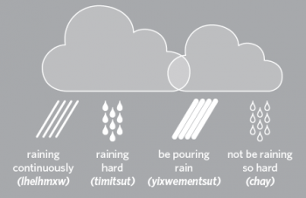Languages are not only important for community identity. They also reflect the unique connection between people and their environment. There may not be 21 words for snow in Inuit, as the apocryphal story goes, but there are certainly 11 words for rain in Squamish, including raining continuously (lhelhmxw), raining hard (timitsut), be pouring rain (yixwementsut) and not be raining so hard (chay).
According to linguist K. David Harrison, co-founder, along with Greg Anderson, of the Living Tongues Institute for Endangered Languages, the areas of highest linguistic diversity (defined as the greatest number of languages per square kilometre) also tend to be areas with the highest biodiversity. Languages in danger can be a clear sign of an environment in distress.
When languages become extinct, the knowledge they contain disappears as well.
Indigenous languages contain ancient knowledge about the natural environment that could help protect biodiversity. “In languages there are invested millennia of environmentally contextualized knowledge systems that the indigenous peoples who speak those languages have acquired,” says Shaw. Ancient languages don’t just encode names but also complex information, as in the way “poison ivy” is both a name and a description.
A local example of ancient knowledge surpassing modern scientific knowledge can be seen in the classification of salmon. In the hən̓q̓əmin̓əm̓ language of the Musqueam, cutthroat trout and steelhead trout are not classified in the trout genus but as salmon. It took a while, but modern science has caught up. According to Shaw, “not until the 1980s did Western genetic scientists working with fish species discover that these two species of so-called trout are actually salmon.”
But when languages become extinct, the knowledge they contain disappears as well – knowledge that could well help us protect biodiversity, maybe even find a life-saving new drug.
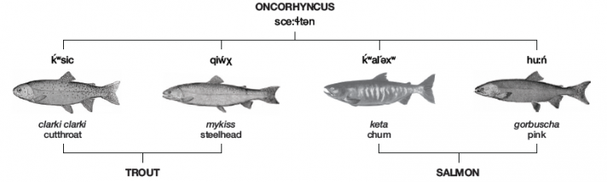
In the hən̓q̓əmin̓əm̓ language on the top, the cutthroat and steelhead “trout” are correctly categorized as salmon. Reprinted with permission from K. David Harrison.

Hope for the Future
Today, efforts are gaining speed to save BC’s First Nations languages while there is still time. Across the province, teachers and language activists like Johnson, Shaw and Grant are paving the way for motivated learners to bring their languages back.
“The interest is beginning to grow,” says Grant. “Right now a lot of things are happening around the value of indigenous knowledge, cultural activities, spirituality and, most important of all, self-identity.” He pauses. “I love seeing the light go on with young people, the ah-ha moment: ‘This is who I am.’”
Novel approaches are being taken by some language activists, usually second-language speakers themselves. Khelsilem (formerly known as Dustin Rivers), for example, is working to revitalize his own language, which has just eight native speakers left. He is planning to spend a year in a language house with three other “twentysomethings,” who will speak only sḵwx̱wú7mesh (Squamish) to each other. He is also the founder of squamishlanguage.com. By creating fluent speakers among 18- to 30-year-olds, Khelsilem’s goal is parents who will raise their families speaking Squamish so “our children’s first language (will be) the same as our great-grandparents’.”
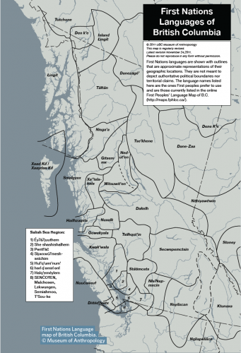According to Bill Poser, adjunct professor of linguistics at UBC, there is still hope for bringing the First Nations languages back from near death. It happened with Hebrew. “Hebrew ceased to be the language of daily communication for the great majority of Jews around 300 BC,” says Poser. “Hebrew survived as a language that people could read, but for the most part it was not a language that people spoke.” Then, in the late 19th century, “a few people decided they were going to use Hebrew at home. Newspapers were published in Hebrew, people started speaking Hebrew with their children, and today Hebrew has come back as the language of daily life in Israel.”
Saving BC’s dying Native languages is a way to help restore communities to health by returning what was, in a very real sense, stolen. It is also a political choice. Says Shaw: “Language is political. It’s political whether we use English or French. Some communities that have held onto the language use it as their secret language; the Nisga’a were known for using the language to talk among themselves while in treaty negotiations to strategize on their own.”
Grant agrees. “Language is very political. If you examine whenever indigenous language is used at a rally or a political event, look at what the response is. It can be visceral.”
Political they may be, but most of all the languages are an irreplaceable heritage. “Who else speaks these languages in the entire world?” asks Shaw. “They are complex systems with rich spiritual traditions – a unique legacy. No one else in the world speaks Haida natively other than those who live in Haida Gwaii. It’s very special.”

